**14. kubernetes Deployment – Demo**

--- Reference - <https://github.com/stacksimplify/kubernetes-fundamentals>

--- Reference - <https://github.com/stacksimplify/kubernetes-fundamentals/tree/master/04-Deployments-with-kubectl>

**Create Deployment**

--- Create Deployment to rollout a ReplicaSet.

--- Verify Deployment, ReplicaSet & Pods.

--- Docker Image Location: <https://hub.docker.com/repository/docker/stacksimplify/kubenginx>, this is the image, we will use for deployment.

**# Create Deployment**

--- **kubectl create deployment <Deplyment-Name> --image=<Container-Image>**

--- **kubectl create deployment my-first-deployment --image=stacksimplify/kubenginx:1.0.0**

**# Verify Deployment**

--- **kubectl get deployments**

--- **kubectl get deploy**

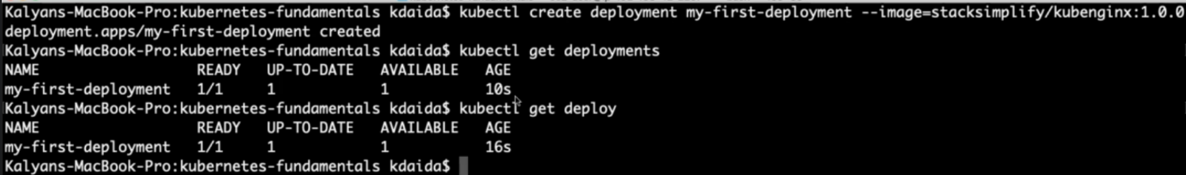

**# Describe Deployment**

--- **kubectl describe deployment <deployment-name>**

--- **kubectl describe deployment my-first-deployment**

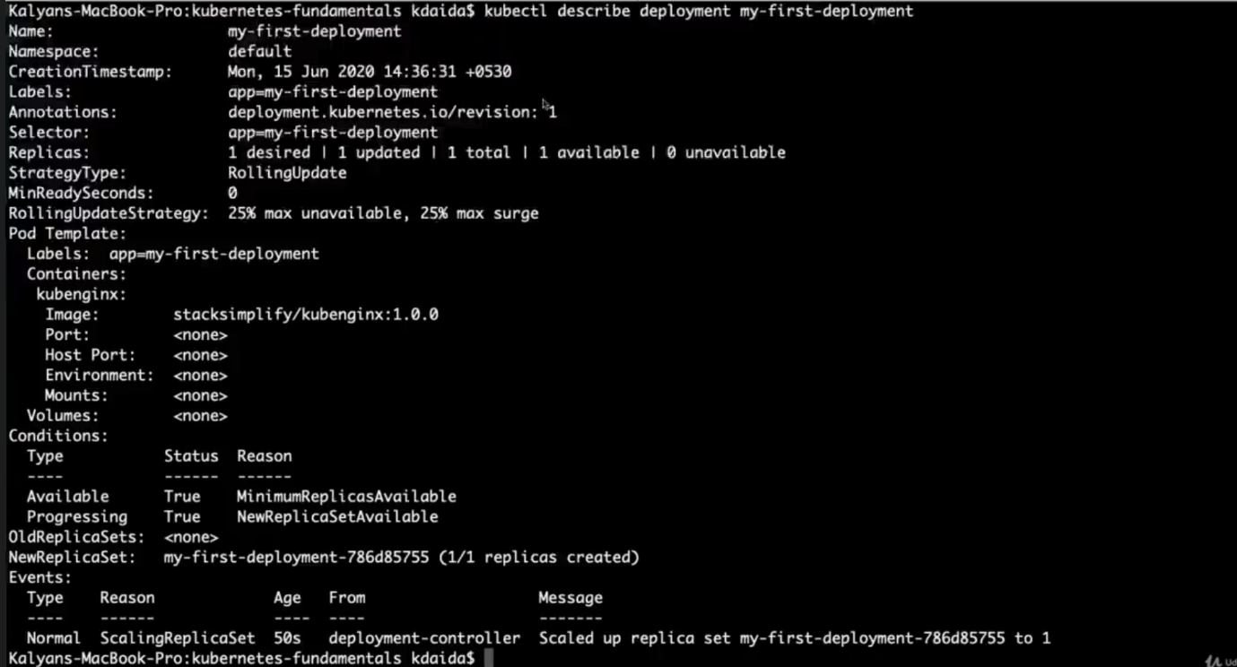

**# Verify ReplicaSet**

--- **kubectl get rs** – we created one rs as part of the deployment.

**# Verify Pod**

--- **kubectl get po** – we created 1 pod as part of the deployment.

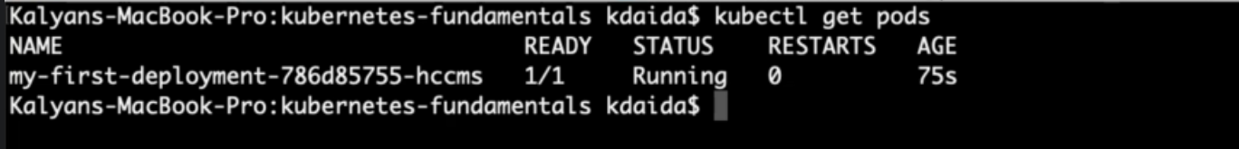

**Scaling a Deployment**

--- **note** - Scale the deployment to increase the number of replicas (pods)

**# Scale Up the Deployment**

--- **kubectl scale --replicas=20 deployment/<Deployment-Name>**

--- **kubectl scale --replicas=20 deployment/my-first-deployment**

**# Verify Deployment**

--- **kubectl get deploy**

**# Verify ReplicaSet**

--- **kubectl get rs**

**# Verify Pods**

--- **kubectl get po**

**# Scale Down the Deployment**

--- **kubectl scale --replicas=10 deployment/my-first-deployment**

--- **kubectl get deploy**

**Expose Deployment as a Service**

--- **note** - Expose Deployment with a service (NodePort Service) to access the application externally (from internet)

**# Expose Deployment as a Service**

--- **kubectl expose deployment <Deployment-Name> --type=NodePort --port=80 --target-port=80 --name=<Service-Name-To-Be-Created>**

--- **kubectl expose deployment my-first-deployment --type=NodePort --port=80 --target-port=80 --name=my-first-deployment-service**

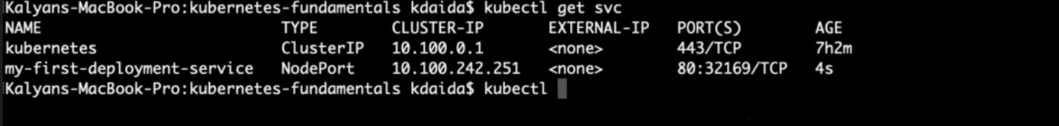

--- **note** – I created service for my deployment.

**# Get Service Info**

--- **kubectl get svc**

Observation: Make a note of port which starts with 3 (Example: 80:3xxxx/TCP). Capture the port 3xxxx and use it in application URL below.

**# Get Public IP of Worker Nodes**

--- **kubectl get nodes -o wide**

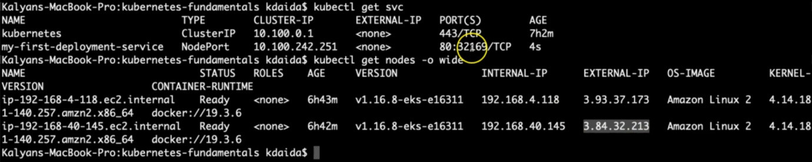

--- **Note** - Make a note of "EXTERNAL-IP" if your Kubernetes cluster is setup on AWS EKS.

**Access the Application using Public IP**

--- **http://<worker-node-public-ip>:<Node-Port>**